**What Are the Characteristics of a Good Leader?**

Leaders shape our nations, communities, and organizations.

We need good leaders to help guide us and make the essential large-scale decisions that keep the world moving.

Our society is usually quick to identify a bad leader, but do we know how to identify a good one? What would most people say makes a good leader?

[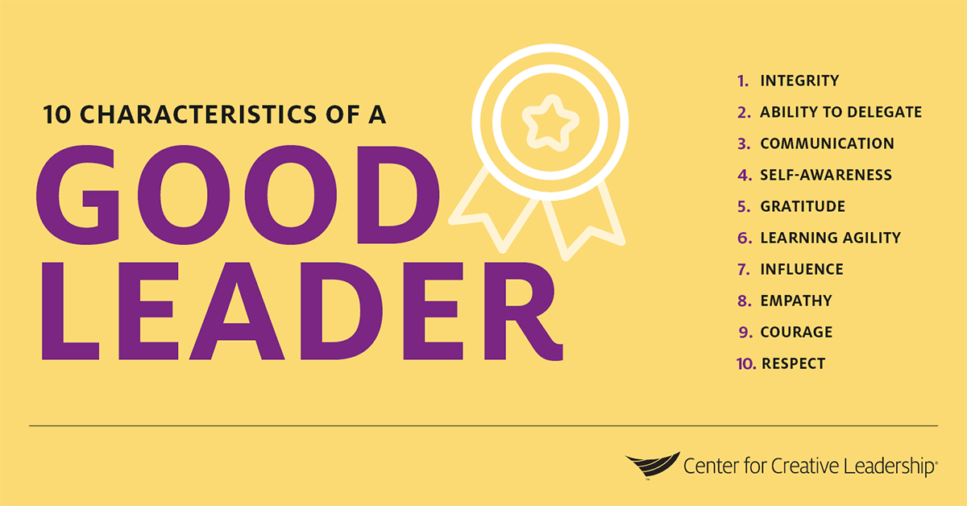](https://www.ccl.org/wp-content/uploads/2020/02/characteristics-of-a-good-leader-center-for-creative-leadership-ccl.png)

Based on our research, we’ve found that great leaders consistently possess these 10 core leadership skills:

* Integrity
* Ability to delegate
* Communication
* Self-awareness
* Gratitude
* Learning agility
* Influence
* Empathy
* Courage
* Respect

**Integrity**

[The importance of integrity](https://www.ccl.org/articles/white-papers/the-irony-of-integrity-a-study-of-the-character-strengths-of-leaders/) should be obvious. Though it may not necessarily be a metric in employee evaluations, integrity is essential for the individual and the organization. It’s especially important for top-level executives who are charting the organization’s course and making countless other significant decisions. Our research show that integrity may actually be a potential blind spot for organizations. Make sure your organization reinforces the importance of integrity to leaders at various levels.

**Ability to Delegate**

Delegating is one of the core responsibilities of a leader, but it can be tricky to delegate effectively. The goal [isn’t just to free yourself up](https://www.ccl.org/articles/leading-effectively-articles/delegating-beyond-getting-it-off-your-desk/) — it’s also to enable your direct reports, facilitate teamwork, provide autonomy, lead to better decision-making, and help your direct reports grow. In order to delegate well, you also need to [build trust with your team](https://www.ccl.org/articles/leading-effectively-articles/build-trust-in-the-workplace/).

**Communication**

Effective leadership and effective communication are intertwined. You need to be able to communicate in a variety of ways, from transmitting information to coaching your people. And you must be able to communicate with a range of people across roles, [social identities](https://www.ccl.org/articles/leading-effectively-articles/understand-social-identity-to-lead-in-a-changing-world/), and more. Follow these [5 tips to be a more effective communicator](https://www.ccl.org/articles/leading-effectively-articles/communication-1-idea-3-facts-5-tips/), and learn how [better conversations](https://www.ccl.org/articles/leading-effectively-articles/communication-1-idea-3-facts-5-tips/) can improve your workplace culture.

**Self-Awareness**

While this is a more inwardly focused skill, self-awareness is paramount for leadership. The better you understand yourself, the more effective you can be. Do you know how other people view you, or how you show up at work? Take the time to learn about [the 4 aspects of self-awareness](https://www.ccl.org/articles/leading-effectively-articles/4-ways-boost-self-awareness/), and how you can dig into each component.

**Gratitude**

[Giving thanks](https://www.ccl.org/articles/leading-effectively-articles/giving-thanks-will-make-you-a-better-leader/) will actually make you a better leader. Gratitude can lead to higher self-esteem, reduced depression and anxiety, and even better sleep. Few people regularly say “thank you” at work, even though most people say they’d be willing to work harder for an appreciative boss. Follow these tips for giving thanks and practicing more gratitude.

**Learning Agility**

Learning agility is the ability to know what to do when you don’t know what to do. If you’re a “quick study” or are able to excel in unfamiliar circumstances, you might already be learning agile. But anybody can foster learning agility through practice, experience, and effort. Explore [the 4 elements of learning agility](https://www.ccl.org/articles/white-papers/great-leaders-are-great-learners-how-to-develop-learning-agile-high-potentials/) to get started.

**Influence**

For some people, “influence” feels like a dirty word. But being able to convince people through logical, emotional, or cooperative appeals is a component of being an inspiring, effective leader. Influence is quite different from manipulation, and it needs to be done authentically and transparently. It requires emotional intelligence and trust-building. Find out how to build [the 4 keys to influencing others](https://www.ccl.org/articles/leading-effectively-articles/4-keys-strengthen-ability-influence-others/).

**Empathy**

Empathy is correlated with job performance. If you show more empathy towards your direct reports, our research shows you’re more likely to be viewed as a better performer by your boss. Empathy can be learned, and in addition to making you more effective, it will also improve work for you and those around you. Organizations can follow these [5 steps to encourage empathy at work](https://www.ccl.org/articles/white-papers/empathy-in-the-workplace-a-tool-for-effective-leadership/).

**Courage**

It can be hard to speak up at work, whether you want to voice a new idea, provide feedback to a direct report, or flag a concern for someone above you. That’s part of the reason courage is a key skill for good leaders. Rather than avoiding problems or allowing conflicts to fester, courage enables leaders to step up and move things in the right direction. Learn more about why [a positive workplace environment and culture requires courage](https://www.ccl.org/articles/white-papers/implementing-coaching-culture/) and truth.

**Respect**

Treating people with respect on a daily basis is one of the most important things a leader can do. It will ease tensions and conflict, create trust, and improve effectiveness. Respect is more than the absence of disrespect, and it can be shown in many different ways. Explore [how you can cultivate a climate of respec](https://www.ccl.org/articles/leading-effectively-articles/the-power-of-respect/)t at work.

Putting It Together: The Characteristics of a Good Leader

While successful leaders may exhibit these 10 leadership skills to varying degrees, all good leaders leverage at least some —or most — of these characteristics. Together, they make up the backbone of leadership across leader levels, industries, and continents. Without these skills, true leadership is impossible.

If you don’t feel like these characteristics of a good leader adequately describe you, don’t panic — there are ways for you to improve on your leadership capabilities, including all 10 of these core skills. At CCL, we believe [that leaders are not born, but made](https://www.ccl.org/blog/leaders-born-made-part-ii/). We know that leaders are molded through experience, continued study, and adaptation. In other words, you can strengthen any of these 10 characteristics and qualities of a good leader if you’re open to growth and you put in the time and effort towards self-improvement. Similarly, organizations can help their people hone these skills through leadership development training and real-world experience.

***[](https://www.leadershipneverstops.org/)***

It’s also essential to realize that leadership is a social process. Leadership isn’t a destination — it’s something that you’ll have to work at regularly throughout your career, regardless of what level you reach in your organization. Leadership is less about a strong or charismatic individual and more about a group of people working together to achieve results. That’s why we say that [leadership is a journey](https://www.leadershipneverstops.org/) — different teams, projects, situations, and organizations will require you to apply these skills in different ways.

We teach our program participants that leadership consists of 3 elements: [direction, alignment, and commitment](https://www.ccl.org/articles/leading-effectively-articles/make-leadership-happen-2/). If you demonstrate several of the characteristics of a good leader but fail to grasp this, chances are you won’t get very far on your own. You may be well liked and respected, but it will be challenging to accomplish team or organizational goals without agreement on objectives, coordination to meet them, and a dedication to making it happen.

Organizations can foster deeper levels of leadership at work through a variety of development opportunities ranging from on-the-job learning to an offsite leadership development program. But individuals don’t have to wait to begin strengthening these characteristics and qualities of a good leader within themselves — you can start today using some of the tips above.

Retrieved May 1, 2020

<https://www.ccl.org/blog/characteristics-good-leader/?utm_campaign=1-Portfolio,2-LE_Article,3-OE&utm_medium=social&utm_source=linkedin&utm_content=1588092753>